==================================================

Running Genetic Algorithm...

==================================================

==================================================

=== GENETIC ALGORITHM OPTIMIZATION ===

==================================================

[Initialization]

- Population size: 30

- Generations: 20

- Crossover rate: 80%

- Mutation rate: 20%

- Search space: 176 features

- Target: Minimize MSE using XGBoost

==================================================

=== OPTIMIZATION RESULTS ===

==================================================

▶ Best MSE achieved: 11080.453080

▶ Time elapsed: 259.95 seconds

▶ Features selected: 89/176 (49.4% reduction)

▶ Selected features:

1. District

2. Neighborhood

3. m² (Gross)

4. m² (Net)

5. Number of rooms

6. Building Age

7. Floor location

8. Number of floors

9. Heating

10. Number of bathrooms

11. Balcony

12. From who

13. Swap

14. Front South

15. Wood Joinery

16. Smart House

17. Alarm (Thief)

18. Alarm (Fire)

19. American Door

20. Balcony.1

21. Household appliances

22. Shower

23. Dressing room

24. Closet

25. Video intercom

26. Jacuzzi

27. Plasterboard

28. Cellar

29. Tub

30. Marley

31. Kitchen (Laminate)

32. Kitchen Natural Gas

33. Blinds

34. Ceramic Floor

35. Spot Lighting

36. Terrace

37. Thermosiphon

38. Cloakroom

39. Steel door

40. Water heater

41. Elevator.1

42. Steam room

43. Security

44. Bath

45. Booster

46. Closed Garage

47. With Private Pool

48. Sauna

49. Tennis court

50. Swimming Pool (Open)

51. Swimming Pool (Indoor)

52. Elevator.2

53. Bathroom

54. Wide Corridor

55. Kitchen

56. Park

57. Socket / Electric Switch

58. The mall

59. Cemevi

60. Next to sea shore

61. Pharmacy

62. Amusement center

63. Fair

64. Hospital

65. The church

66. High school

67. Market

68. Gym

69. Town center

70. Eurasia Tunnel

71. Marmaray

72. Minibus

73. Coast

74. TEM

75. Tram

76. Railway station

77. Scaffolding

78. Sea

79. Nature

80. Pool

81. Park & ​​Green Area

82. City

83. Mezzanine

84. Garden Floor

85. Garden

86. Garage / Shop Top

87. Rerse Duplex

88. Triplex

89. Roof Duplex

▶ Convergence progress:

- Initial MSE: 11654.2312

- Final MSE: 11080.4531

- Improvement: 4.9%

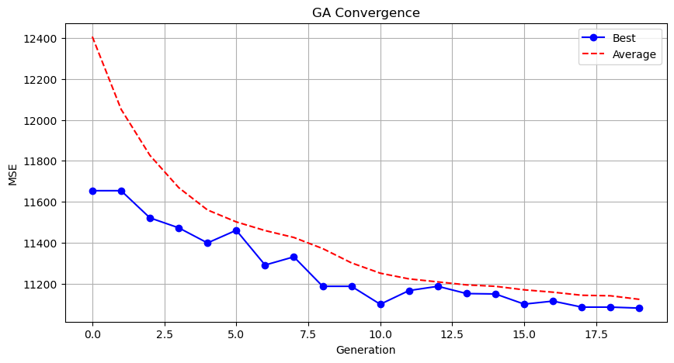

Genetic Algorithm completed successfully with MSE: 11080.4531

==================================================

Running Particle Swarm Optimization...

==================================================

==================================================

=== PARTICLE SWARM OPTIMIZATION ===

==================================================

[Initialization]

- Swarm size: 30 particles

- Iterations: 20

- Cognitive weight: 0.5

- Social weight: 0.5

- Inertia weight: 0.5

- Search space: 176 features

- Target: Minimize MSE using XGBoost

[Optimization Progress]

==================================================

=== OPTIMIZATION RESULTS ===

==================================================

▶ Best MSE achieved: 10818.576393

▶ Time elapsed: 285.87 seconds

▶ Features selected: 105/176 (40.3% reduction)

▶ Selected features (with weights):

1. District (weight: 0.738)

2. Neighborhood (weight: 0.654)

3. m² (Gross) (weight: 1.000)

4. Number of rooms (weight: 0.940)

5. Building Age (weight: 0.560)

6. Floor location (weight: 1.000)

7. Number of floors (weight: 0.587)

8. Heating (weight: 0.956)

9. Balcony (weight: 0.689)

10. Using status (weight: 0.520)

11. Available for Loan (weight: 0.634)

12. Front West (weight: 0.820)

13. Front East (weight: 0.773)

14. Front South (weight: 0.577)

15. Front North (weight: 0.588)

16. ADSL (weight: 0.652)

17. Wood Joinery (weight: 0.929)

18. Smart House (weight: 0.654)

19. Alarm (Fire) (weight: 0.524)

20. Aluminum joinery (weight: 0.699)

21. Elevator (weight: 0.659)

22. Household appliances (weight: 0.752)

23. Painted (weight: 0.606)

24. Dishwasher (weight: 0.532)

25. Refrigerator (weight: 0.605)

26. Dressing room (weight: 0.631)

27. Video intercom (weight: 0.940)

28. Hilton Bathroom (weight: 0.510)

29. Intercom System (weight: 0.936)

30. Insulating glass (weight: 0.776)

31. Plasterboard (weight: 0.551)

32. Tub (weight: 0.572)

33. Laminate Floor (weight: 0.888)

34. Furniture (weight: 0.950)

35. Kitchen (Built-in) (weight: 1.000)

36. Kitchen (Laminate) (weight: 0.560)

37. PVC Joinery (weight: 0.744)

38. Blinds (weight: 0.847)

39. Parquet Floor (weight: 0.942)

40. Ceramic Floor (weight: 1.000)

41. Spot Lighting (weight: 0.656)

42. Thermosiphon (weight: 0.891)

43. Cloakroom (weight: 0.537)

44. Wi-Fi (weight: 0.809)

45. Washing Machine (weight: 0.570)

46. Washing machine (weight: 0.952)

47. Water heater (weight: 0.554)

48. Fireplace (weight: 0.579)

49. Elevator.1 (weight: 0.945)

50. Steam room (weight: 0.797)

51. Security (weight: 0.541)

52. Cable TV (weight: 0.745)

53. Closed Garage (weight: 0.649)

54. Doorman (weight: 0.771)

55. Nursery (weight: 0.754)

56. With Private Pool (weight: 0.558)

57. Car park (weight: 0.721)

58. Sauna (weight: 0.547)

59. Sound insulation (weight: 0.714)

60. Siding (weight: 0.773)

61. Sports Area (weight: 0.670)

62. Water tank (weight: 0.550)

63. Tennis court (weight: 0.980)

64. Satellite (weight: 0.813)

65. Swimming Pool (Open) (weight: 0.885)

66. Swimming Pool (Indoor) (weight: 0.682)

67. Parking Lot (weight: 0.802)

68. Bathroom (weight: 0.525)

69. Entrance / Ramp (weight: 0.570)

70. Socket / Electric Switch (weight: 0.752)

71. Toilet (weight: 0.865)

72. Swimming pool (weight: 1.000)

73. Mosque (weight: 1.000)

74. Pharmacy (weight: 0.866)

75. Fair (weight: 1.000)

76. Synagogue (weight: 0.875)

77. High school (weight: 0.597)

78. The health clinic (weight: 0.977)

79. District Market (weight: 0.628)

80. Gym (weight: 0.678)

81. Fire Department (weight: 0.771)

82. Highway (weight: 0.525)

83. Eurasia Tunnel (weight: 0.651)

84. Bosphorus Bridges (weight: 1.000)

85. Sea bus (weight: 0.655)

86. E-5 (weight: 1.000)

87. Marmaray (weight: 0.651)

88. Metro (weight: 0.736)

89. Coast (weight: 0.907)

90. TEM (weight: 0.519)

91. Railway station (weight: 0.715)

92. Trolley bus (weight: 0.832)

93. Throat (weight: 1.000)

94. Nature (weight: 0.537)

95. Lake (weight: 0.767)

96. Park & ​​Green Area (weight: 0.727)

97. City (weight: 0.508)

98. Mezzanine (weight: 0.592)

99. Garden Floor (weight: 0.806)

100. Garden (weight: 0.902)

101. Top floor (weight: 1.000)

102. Garage / Shop Top (weight: 0.543)

103. Rerse Duplex (weight: 1.000)

104. Triplex (weight: 0.856)

105. Roof Duplex (weight: 0.816)

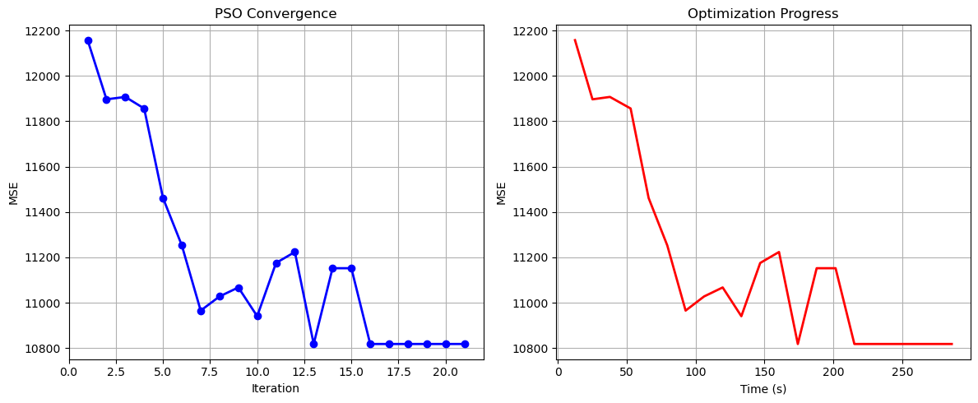

Particle Swarm Optimization completed successfully with MSE: 10818.5764

==================================================

Running Whale Optimization...

==================================================

==================================================

=== WHALE OPTIMIZATION ALGORITHM ===

==================================================

[Initialization]

- Population: 30 whales

- Max iterations: 20

- Spiral coefficient (b): 1.0

- Search space: 176 features

- Target: Minimize MSE using XGBoost

[Optimization Progress]

Iter 20/20 | Best MSE: 10980.444341

==================================================

=== OPTIMIZATION RESULTS ===

==================================================

▶ Best MSE achieved: 10980.444341

▶ Time elapsed: 348.74 seconds

▶ Features selected: 164/176 (6.8% reduction)

▶ Selected features:

1. District

2. Neighborhood

3. m² (Gross)

4. m² (Net)

5. Number of rooms

6. Building Age

7. Floor location

8. Number of floors

9. Heating

10. Number of bathrooms

11. Balcony

12. Furnished

13. Using status

14. Available for Loan

15. From who

16. Swap

17. Front West

18. Front East

19. Front South

20. Front North

21. ADSL

22. Wood Joinery

23. Smart House

24. Alarm (Thief)

25. Alarm (Fire)

26. Alaturka Toilet

27. American Door

28. American kitchen

29. Elevator

30. Balcony.1

31. Barbecue

32. Household appliances

33. Painted

34. Dishwasher

35. Refrigerator

36. Wall paper

37. Shower

38. Parents' Bathroom

39. Fiber Internet

40. Dressing room

41. Closet

42. Video intercom

43. Hilton Bathroom

44. Intercom System

45. Plasterboard

46. Cellar

47. Air conditioning

48. Tub

49. Laminate Floor

50. Marley

51. Furniture

52. Kitchen (Built-in)

53. Kitchen Natural Gas

54. PVC Joinery

55. Blinds

56. Parquet Floor

57. Ceramic Floor

58. Set Top Cooker

59. Spot Lighting

60. Terrace

61. Thermosiphon

62. Cloakroom

63. Wi-Fi

64. Face Recognition & Fingerprint

65. Washing Machine

66. Washing machine

67. Laundry room

68. Steel door

69. Water heater

70. Fireplace

71. Elevator.1

72. Steam room

73. Security

74. Bath

75. Booster

76. Generator

77. Cable TV

78. Closed Garage

79. Doorman

80. Nursery

81. With Private Pool

82. Car park

83. Playground

84. Sauna

85. Sound insulation

86. Siding

87. Sports Area

88. Water tank

89. Tennis court

90. Satellite

91. Fire escape

92. Swimming Pool (Open)

93. Swimming Pool (Indoor)

94. Parking Lot

95. Elevator.2

96. Bathroom

97. Wide Corridor

98. Entrance / Ramp

99. Stairs

100. Kitchen

101. Room door

102. Park

103. Socket / Electric Switch

104. Handle / Railing

105. Toilet

106. Swimming pool

107. The mall

108. municipality

109. Mosque

110. Cemevi

111. Next to sea shore

112. Pharmacy

113. Amusement center

114. Fair

115. Hospital

116. The church

117. High school

118. Market

119. Park.1

120. Police station

121. The health clinic

122. District Market

123. Gym

124. Unirsity

125. Primary School-Secondary School

126. Fire Department

127. Town center

128. Highway

129. Eurasia Tunnel

130. Bosphorus Bridges

131. Street

132. Sea bus

133. Filled

134. E-5

135. Airport

136. Marmaray

137. Metrobus

138. Minibus

139. Bus stop

140. Coast

141. TEM

142. Cable car

143. Tram

144. Railway station

145. Trolley bus

146. Throat

147. Sea

148. Nature

149. Lake

150. Pool

151. Park & ​​Green Area

152. City

153. Mezzanine

154. Mezzanine Duplex

155. Garden Duplex

156. Garden Floor

157. Top floor

158. Entrance floor

159. Floor Duplex

160. Private Entry

161. Rerse Duplex

162. Triplex

163. Ground floor

164. Roof Duplex

▶ Convergence progress:

- Initial MSE: 13763.2847

- Final MSE: 10980.4443

- Improvement: 20.2%

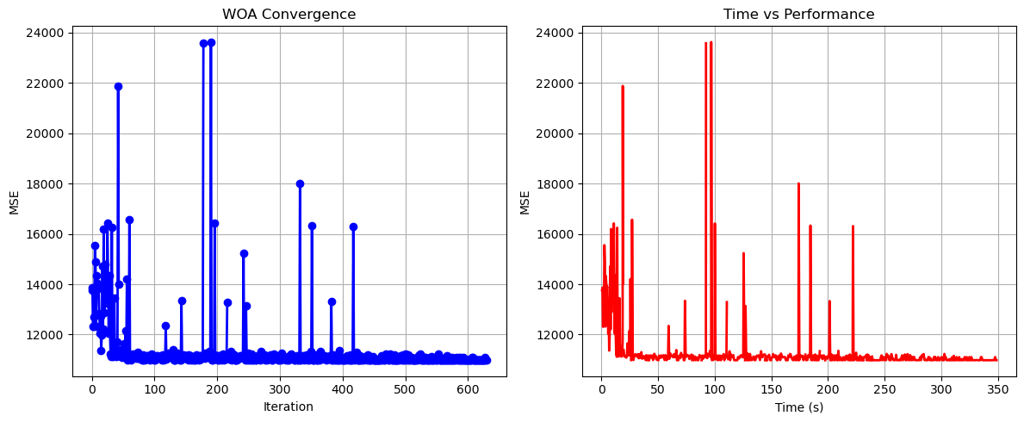

Whale Optimization completed successfully with MSE: 10980.4443

==================================================

Running Squid Game Optimizer...

==================================================

==================================================

=== SQUID GAME OPTIMIZER (SGO) ===

==================================================

[Initialization]

- Players: 30 (15 offensive, 15 defensive)

- Max games: 20

- Search space: 176 features

- Target: Minimize MSE using XGBoost

==================================================

=== OPTIMIZATION RESULTS ===

==================================================

▶ Best MSE achieved: 10994.139413

▶ Time elapsed: 252.66 seconds

▶ Features selected: 73/176 (58.5% reduction)

▶ Selected features:

1. District

2. Neighborhood

3. m² (Gross)

4. Number of rooms

5. Building Age

6. Floor location

7. Number of floors

8. Heating

9. Furnished

10. Available for Loan

11. From who

12. Swap

13. Smart House

14. Alarm (Thief)

15. Alaturka Toilet

16. Aluminum joinery

17. Barbecue

18. Painted

19. Dishwasher

20. Shower

21. Parents' Bathroom

22. Fiber Internet

23. On

24. Dressing room

25. Insulating glass

26. Plasterboard

27. Air conditioning

28. Tub

29. Laminate Floor

30. Kitchen (Laminate)

31. Kitchen Natural Gas

32. PVC Joinery

33. Blinds

34. Parquet Floor

35. Ceramic Floor

36. Set Top Cooker

37. Terrace

38. Face Recognition & Fingerprint

39. Washing Machine

40. Water heater

41. Fireplace

42. Elevator.1

43. Steam room

44. Bath

45. Closed Garage

46. Car park

47. Playground

48. Siding

49. Elevator.2

50. Bathroom

51. Room door

52. Handle / Railing

53. Mosque

54. Park.1

55. The health clinic

56. District Market

57. Gym

58. Primary School-Secondary School

59. Eurasia Tunnel

60. Bosphorus Bridges

61. Sea bus

62. E-5

63. Marmaray

64. Minibus

65. Cable car

66. Railway station

67. Sea

68. Lake

69. Garden Floor

70. Garden

71. Entrance floor

72. Triplex

73. Ground floor

▶ Convergence progress:

- Initial MSE: 11493.6432

- Final MSE: 10994.1394

- Improvement: 4.3%

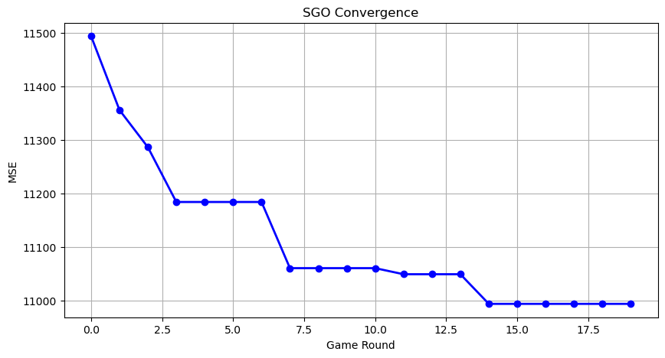

Squid Game Optimizer completed successfully with MSE: 10994.1394

==================================================

Running PSH-Hyptrite...

==================================================

==================================================

=== PSH-HYPTRITE OPTIMIZATION ===

==================================================

[Initialization]

- Search points: 30

- Max iterations: 20

- Initial radius: 0.5 (adaptive)

- Hypersphere samples: 3 per point

- Search space: 176 features

- Target: Minimize MSE using XGBoost

[Optimization Progress]

Iter 20/20 | Best MSE: 11115.269463 | Radius: 0.0250

==================================================

=== OPTIMIZATION RESULTS ===

==================================================

▶ Best MSE achieved: 11115.269463

▶ Time elapsed: 791.51 seconds

▶ Features selected: 95/176 (46.0% reduction)

▶ Selected features (with weights):

1. District (weight: 0.617)

2. Neighborhood (weight: 0.600)

3. m² (Gross) (weight: 0.775)

4. m² (Net) (weight: 0.813)

5. Number of rooms (weight: 0.549)

6. Building Age (weight: 0.999)

7. Floor location (weight: 0.798)

8. Number of floors (weight: 0.544)

9. Heating (weight: 0.640)

10. Furnished (weight: 0.678)

11. Using status (weight: 0.665)

12. Available for Loan (weight: 0.859)

13. Front East (weight: 0.784)

14. Wood Joinery (weight: 0.658)

15. Alarm (Fire) (weight: 0.622)

16. Alaturka Toilet (weight: 0.536)

17. American kitchen (weight: 0.913)

18. Elevator (weight: 0.674)

19. Dishwasher (weight: 0.895)

20. Wall paper (weight: 0.614)

21. Shower (weight: 0.872)

22. Parents' Bathroom (weight: 0.999)

23. On (weight: 0.695)

24. Closet (weight: 0.643)

25. Hilton Bathroom (weight: 0.673)

26. Cellar (weight: 0.774)

27. Air conditioning (weight: 0.577)

28. Tub (weight: 0.839)

29. Laminate Floor (weight: 0.765)

30. Furniture (weight: 0.589)

31. Kitchen Natural Gas (weight: 0.642)

32. PVC Joinery (weight: 0.718)

33. Ceramic Floor (weight: 0.548)

34. Terrace (weight: 0.682)

35. Laundry room (weight: 0.513)

36. Water heater (weight: 0.991)

37. Fireplace (weight: 0.642)

38. Elevator.1 (weight: 0.770)

39. Steam room (weight: 0.704)

40. Security (weight: 0.953)

41. Booster (weight: 0.983)

42. Generator (weight: 0.676)

43. Closed Garage (weight: 0.938)

44. Doorman (weight: 0.994)

45. Nursery (weight: 0.995)

46. With Private Pool (weight: 0.559)

47. Car park (weight: 0.994)

48. Playground (weight: 0.858)

49. Sauna (weight: 0.956)

50. Sound insulation (weight: 0.694)

51. Siding (weight: 0.997)

52. Sports Area (weight: 0.547)

53. Water tank (weight: 0.543)

54. Fire escape (weight: 0.573)

55. Swimming Pool (Open) (weight: 0.924)

56. Swimming Pool (Indoor) (weight: 0.695)

57. Parking Lot (weight: 0.802)

58. Toilet (weight: 0.969)

59. Swimming pool (weight: 0.666)

60. The mall (weight: 0.550)

61. municipality (weight: 0.946)

62. Cemevi (weight: 0.630)

63. High school (weight: 0.987)

64. Park.1 (weight: 0.995)

65. The health clinic (weight: 0.985)

66. Fire Department (weight: 0.538)

67. Town center (weight: 0.790)

68. Bosphorus Bridges (weight: 0.912)

69. Street (weight: 0.797)

70. Sea bus (weight: 0.958)

71. E-5 (weight: 0.807)

72. Airport (weight: 0.813)

73. Metro (weight: 0.876)

74. Bus stop (weight: 0.752)

75. Coast (weight: 0.837)

76. Cable car (weight: 0.931)

77. Tram (weight: 0.585)

78. Railway station (weight: 0.566)

79. Scaffolding (weight: 0.863)

80. Throat (weight: 0.881)

81. Nature (weight: 0.893)

82. Lake (weight: 0.541)

83. Mezzanine (weight: 0.579)

84. Mezzanine Duplex (weight: 0.803)

85. Garden Floor (weight: 0.509)

86. Garden (weight: 0.625)

87. Top floor (weight: 0.803)

88. Garage / Shop Top (weight: 0.733)

89. Entrance floor (weight: 0.957)

90. Floor Duplex (weight: 0.880)

91. Private Entry (weight: 0.814)

92. Rerse Duplex (weight: 0.794)

93. Triplex (weight: 0.772)

94. Ground floor (weight: 0.943)

95. Roof Duplex (weight: 0.708)

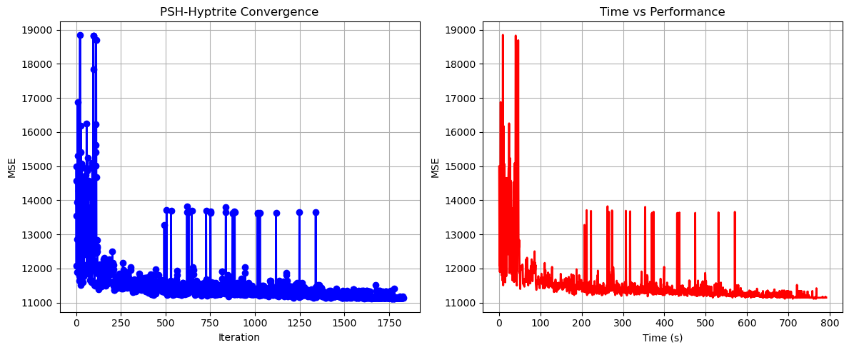

PSH-Hyptrite completed successfully with MSE: 11115.2695

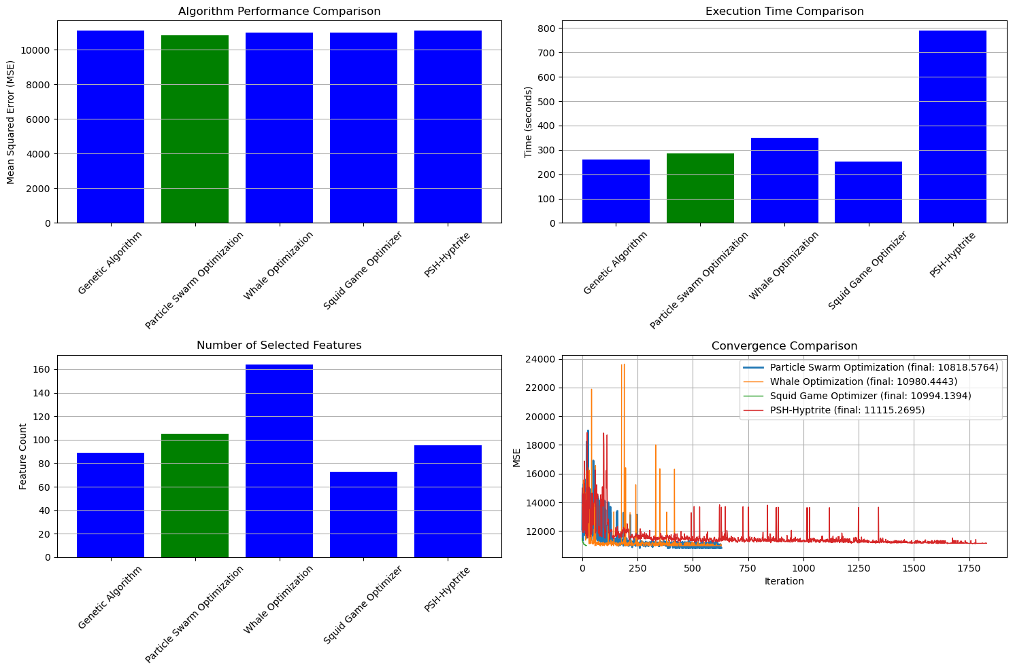

==================================================

FINAL RESULTS SUMMARY

==================================================

🏆 Best Algorithm: Particle Swarm Optimization

📉 Best MSE Achieved: 10818.576393

⏱️ Execution Time: 285.87 seconds

🔢 Features Selected: 105

Selected Features:

1. District

2. Neighborhood

3. m² (Gross)

4. Number of rooms

5. Building Age

6. Floor location

7. Number of floors

8. Heating

9. Balcony

10. Using status

11. Available for Loan

12. Front West

13. Front East

14. Front South

15. Front North

16. ADSL

17. Wood Joinery

18. Smart House

19. Alarm (Fire)

20. Aluminum joinery

21. Elevator

22. Household appliances

23. Painted

24. Dishwasher

25. Refrigerator

26. Dressing room

27. Video intercom

28. Hilton Bathroom

29. Intercom System

30. Insulating glass

31. Plasterboard

32. Tub

33. Laminate Floor

34. Furniture

35. Kitchen (Built-in)

36. Kitchen (Laminate)

37. PVC Joinery

38. Blinds

39. Parquet Floor

40. Ceramic Floor

41. Spot Lighting

42. Thermosiphon

43. Cloakroom

44. Wi-Fi

45. Washing Machine

46. Washing machine

47. Water heater

48. Fireplace

49. Elevator.1

50. Steam room

51. Security

52. Cable TV

53. Closed Garage

54. Doorman

55. Nursery

56. With Private Pool

57. Car park

58. Sauna

59. Sound insulation

60. Siding

61. Sports Area

62. Water tank

63. Tennis court

64. Satellite

65. Swimming Pool (Open)

66. Swimming Pool (Indoor)

67. Parking Lot

68. Bathroom

69. Entrance / Ramp

70. Socket / Electric Switch

71. Toilet

72. Swimming pool

73. Mosque

74. Pharmacy

75. Fair

76. Synagogue

77. High school

78. The health clinic

79. District Market

80. Gym

81. Fire Department

82. Highway

83. Eurasia Tunnel

84. Bosphorus Bridges

85. Sea bus

86. E-5

87. Marmaray

88. Metro

89. Coast

90. TEM

91. Railway station

92. Trolley bus

93. Throat

94. Nature

95. Lake

96. Park & ​​Green Area

97. City

98. Mezzanine

99. Garden Floor

100. Garden

101. Top floor

102. Garage / Shop Top

103. Rerse Duplex

104. Triplex

105. Roof Duplex